LAB #05

Spectral Analysis of a random signal using MATLAB



Fall 2023

**CSE-402L Digital Signal Processing Lab**

Submitted by: MUHAMMAD SADEEQ

Registration No.: 21PWCSE2028

Section: C

“On my honor, as a student of the University of Engineering and Technology, I have neither given nor received unauthorized assistance on this academic work”

Submitted to:

Dr. Yasir Saleem Afridi

(26 Nov 2023)

Department of Computer systems engineering

University of Engineering and Technology, Peshawar

**Task 1**

**Code:**

% Set the sampling frequency

fs = 1000; % Hz

% Create a time vector from 0 to 0.25 seconds with steps of 1 millisecond

t = 0:1/fs:0.25; % seconds

% Create a signal, x, containing sine waves at 50 Hz and 120 Hz

x = sin(2*pi*50*t) + sin(2*pi*120*t); % volts

% Plot the signal

plot(t,x)

xlabel('Time (s)')

ylabel('Voltage (V)')

title('Signal with sine waves at 50 Hz and 120 Hz')

**Output:**

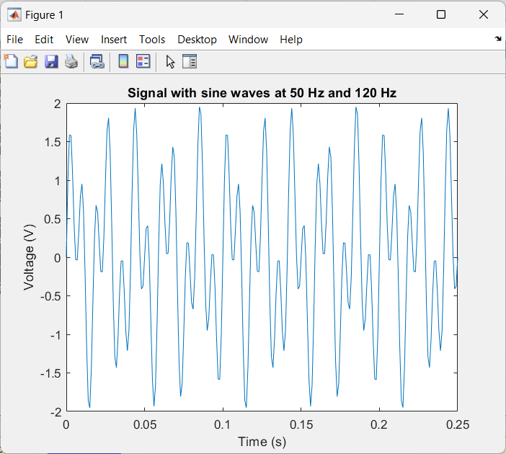

**Task 2**

**Code:**

% Set the standard deviation of the noise

sigma = 2; % volts

% Generate a random noise vector with the same size as t

noise = sigma * randn(size(t)); % volts

% Add the noise to the signal x to get the noisy signal y

y = x + noise; % volts

% Plot the noisy signal y

plot(t,y)

xlabel('Time (s)')

ylabel('Voltage (V)')

title('Noisy signal with sine waves at 50 Hz and 120 Hz')

**Output:**

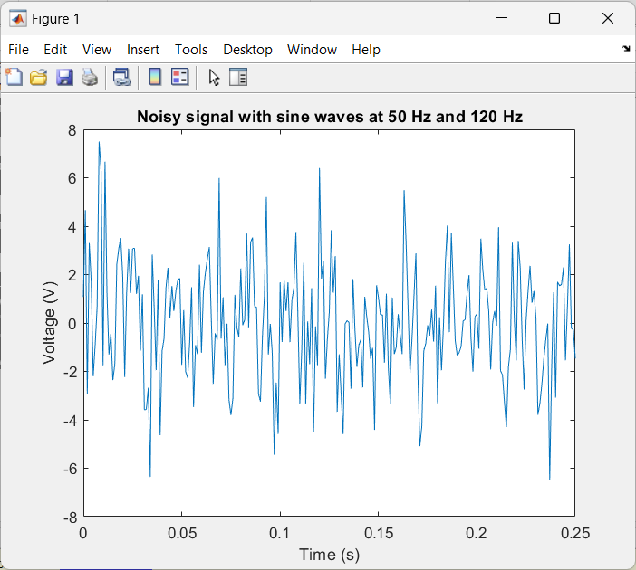

**Task 3**

**Code:**

% Set the number of points for the DFT

N = 251; % samples

% Compute the DFT of the noisy signal y using the fft function

Y = fft(y,N); % volts

% Plot the magnitude spectrum of the DFT

f = (0:N-1) * fs / N; % frequency vector in Hz

plot(f,abs(Y))

xlabel('Frequency (Hz)')

ylabel('Magnitude (V)')

title('Magnitude spectrum of the noisy signal y')

**Output:**

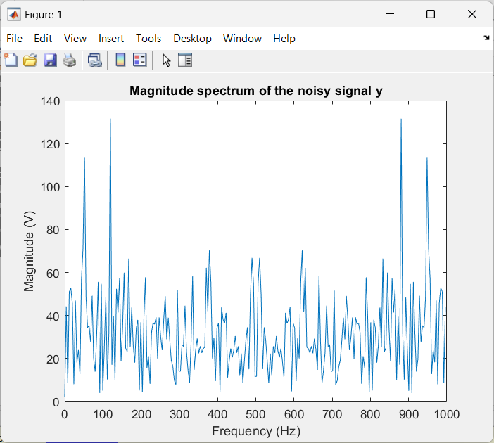

**Task 4**

**Code:**

% Compute the PSD of the noisy signal y using the CONJ function

Pyy = Y.*conj(Y)/N; % power per frequency in V^2/Hz

% Form a frequency axis for the first 127 points

f = fs/N * (0:127); % frequency vector in Hz

% Plot the PSD of the noisy signal y

plot(f,Pyy(1:128))

xlabel('Frequency (Hz)')

ylabel('Power (V^2/Hz)')

title('Power spectral density of the noisy signal y')

**Output:**

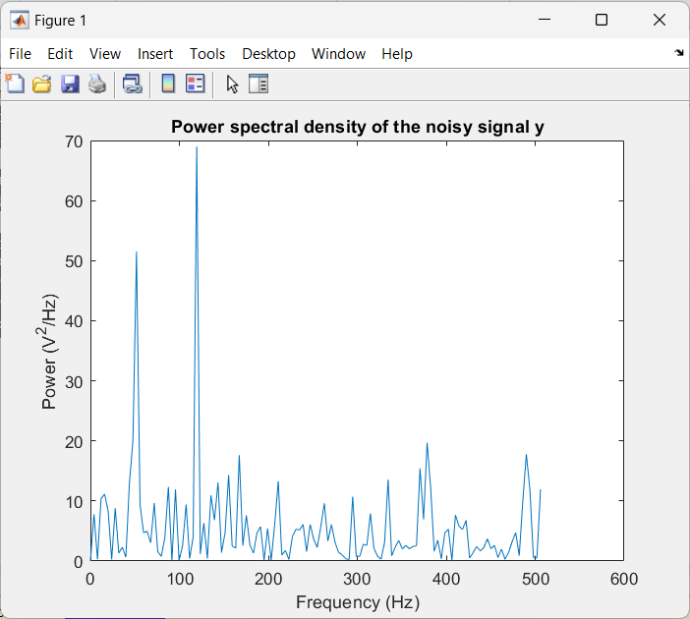

**Task 5**

**Code:**

figure;

plot(f,Pyy(1:128),'b'); % PSD using complex conjugate

hold on;

plot(w,10*log10(Pyy2),'r--'); % PSD using periodogram

hold off;

xlabel('Frequency (Hz)');

ylabel('Power (V^2/Hz)');

title('Power spectral density of the noisy signal y');

legend('Complex conjugate','Periodogram');

**Output:**

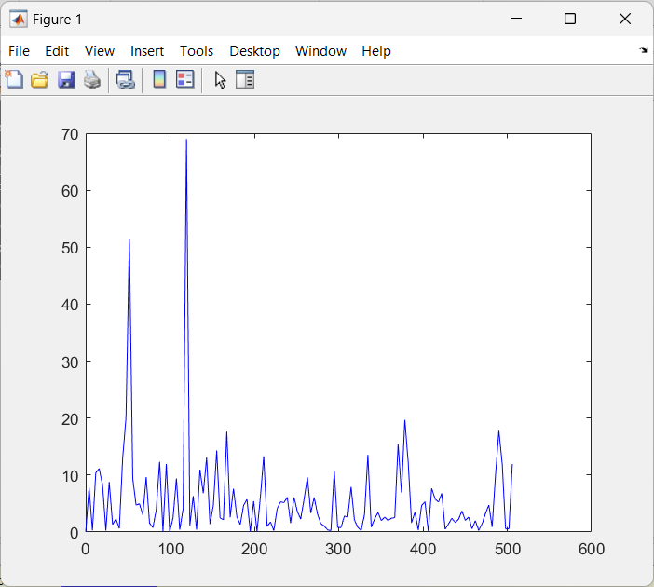

**Task 6**

**Code:**

% Set the frequency limit

fmax = 200; % Hz

% Find the index of the frequency vector that corresponds to the limit

imax = find(f <= fmax, 1, 'last');

% Plot the PSD of the noisy signal y up to 200 Hz

plot(f(1:imax),Pyy(1:imax))

xlabel('Frequency (Hz)')

ylabel('Power (V^2/Hz)')

title('Power spectral density of the noisy signal y up to 200 Hz')

**Output:**

